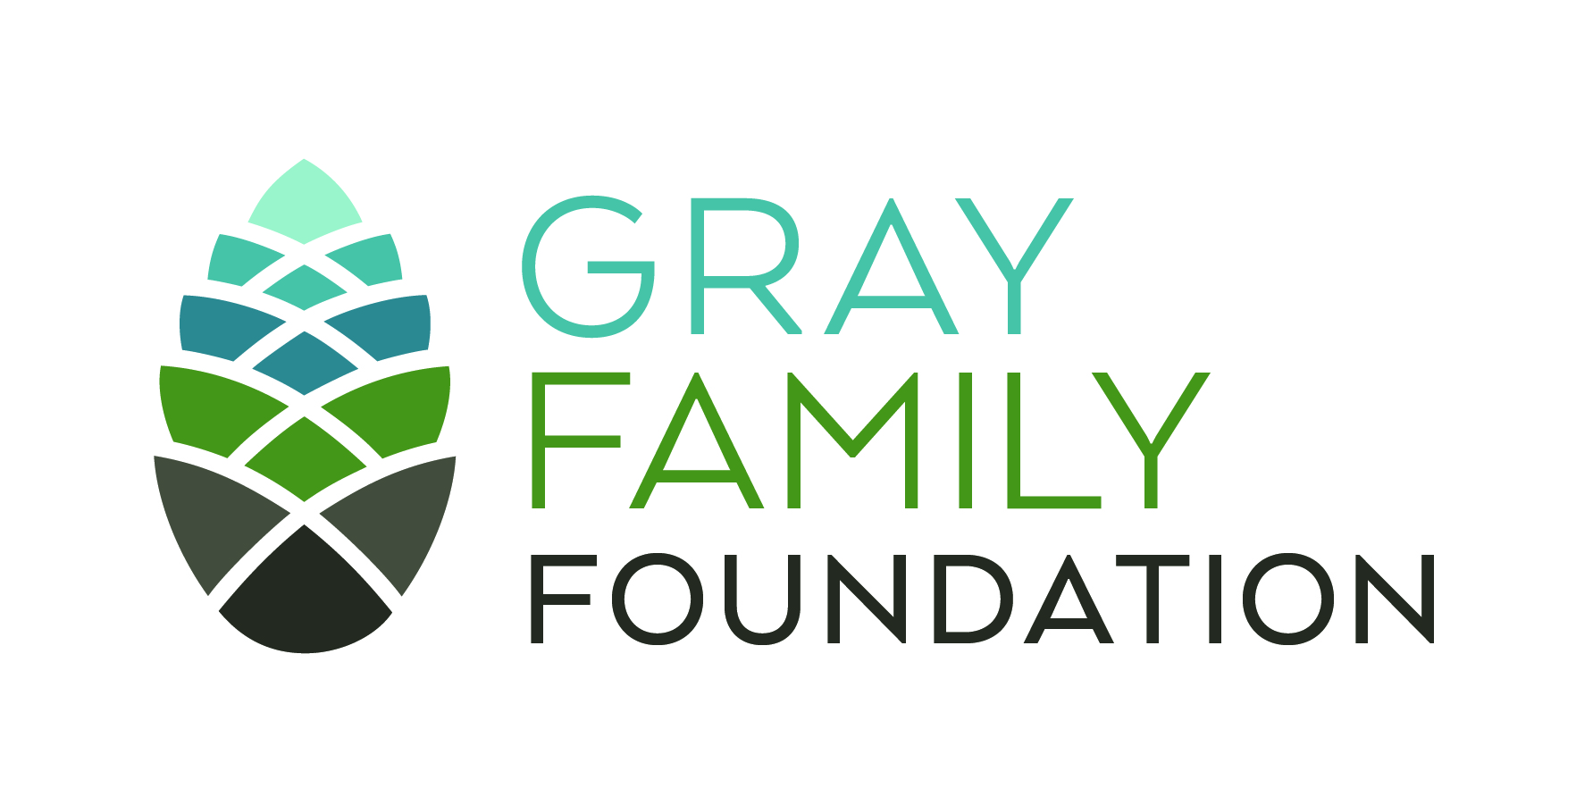

Gray Family Foundation
Grant Storytelling and Renewal Request Form

You may recreate and expand this form on your computer or download it from our website at www.grayff.org

Organization name: Date submitted:

Contact person/Title:

Address: Phone:

Amount of grant:

All grantees

- What county or counties in Oregon benefited from the programming supported through this grant?

- How many K-12 students benefited from the programming supported through this grant? Please specify grade-levels or write N/A if not applicable.

- If applicable, how many total hours did each individual student participate in programming = (e.g. each student participated in 6 hours of programming over three sessions).

- How many educators (formal or non-formal) benefited from the programming supported by this funding? Please specify grade-levels supported by educators or write N/A if not applicable.

- If applicable, how many total hours did each individual educator participate in training or professional development (e.g. each educator participated in 2 hours of training over two sessions).

- What do you want us to know about your work over the grant period?

- What are the strategic questions or challenges you are grappling with?

- How can we help?

- Sometimes the positive impact of a project is not easy to communicate via measurable results. If that is true of your project, please share with us a story that illustrates the effect the project has had.

- The Gray Family Foundation also invites you to submit photographs (300 dpi or larger) of your project. If you have images to share, please contact us at grants@grayff.org. The photographs and stories shared here might be used on our website or in foundation publications. If you are willing to share your images, we would be happy to send you a copy of our photo release form. Thank you for considering our invitation when planning and implementing your program.

To be completed by approved multi-year applicants only (Grant renewal request – please refer to your award letter for eligible request amount)

- Renewal amount requested:

- What do you propose to do with another year of funding?

- How will you build on your successes and lessons learned from the previous year?

Signature and Title Date

Please submit your electronic evaluation and expenditure information to grants@grayff.org or call 503-552-3500.

